### **Soal Eksplorasi (20)**

1. Tulis kesimpulan dari hasil pengujian berikut.

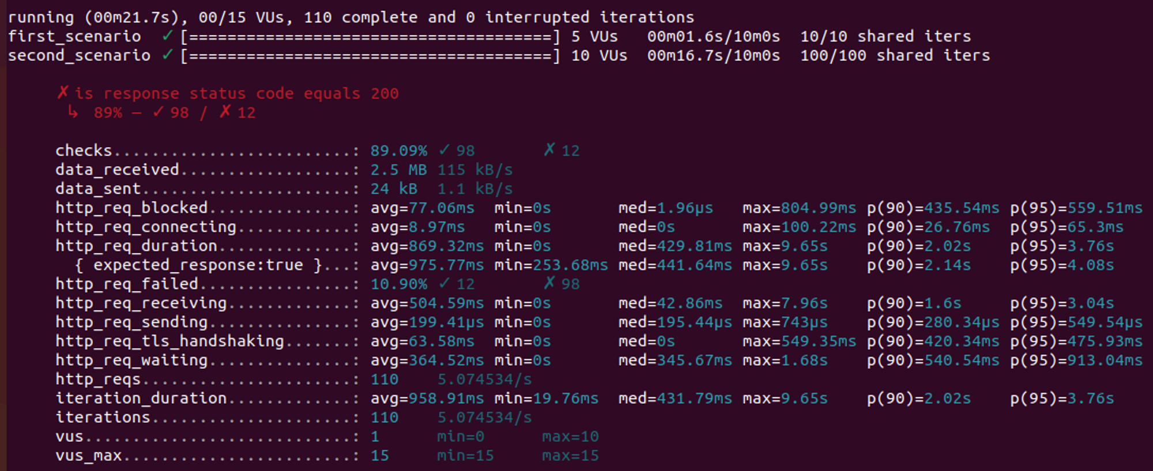

Jawaban :

berjalan dengan kecepatan (00m21. 7s), 00/15 VUs, 110 iterasi selesai dan terputus.

skenario pertama 5VUs 00m01.6s/10m0s 10/10 berbagi iters.

skenario kedua 10VUs 00n16.7s/10n0s 100/100 iters bersama.

kode status respons sama dengan 200

= 89% - 98 / x 12

cek : 89,09% v 98 x 12

data telah diterima : 2,5 MB 115 kB/dtk

data_terkirim : 24 kB 1,1 kB/dtk

http_req_block : rata - rata 77,06ns min=0s ned = 1.96 max = 804.99 ns p(95)=559 5 ins

http_req_menghubungkan : rata - rata 8,97 mdtk = 0 dtk ned = 429.81 ms max = 9.65dtk

http_req_durasi : raa - rata 504,59 mdtk = 0dtk ned = 429.81ms = 9.65s p(90)=2,025 p(95)=376dtk

ekspektasi respon : benar rata - rata 975,77ms mtn-253,68ns ned = 441,64ms maks = 9,65s

http_req_gagal 10,90% berhasil = 12 gagal = 98

http_req_menerima : rata - rata = 504,59 mdtk = d ned = 42.86ms max = 7.96s P(90) = 1,6 dtk P(95) = 3,04%

http_req_pengiriman : rata - rata = 199,41 us min = 0 dtk ned = 195.44us maks = 743us p(90) 280.34us p(95) = 549.54ps

http_req_jabat tangan : avg = 63.58ns min = 0s ned = 0s Maks = 549.35ms p(90) 420.34ns p(95) = 475.93ms

http_req_menunggu : rata = 364,52ns min = 0dtk ned = 345.67ms maks = 1.68dtk

http_reqs : 110 5,074534/dtk

iterasi_durasi : rata - rata = 958.91ms min = 19.76ns ned = 431.79ms maks = 9.65dtk p(90) = 2,02s p(95) 3,76dtk

iterasi :110 5,074534/dtk

vus : min = 0 maks = 10

vs maks : 15, min = 15maks = 15

*Referensi Jawaban : google translate*